
nsw darts
Policy on Drugs

October 2018

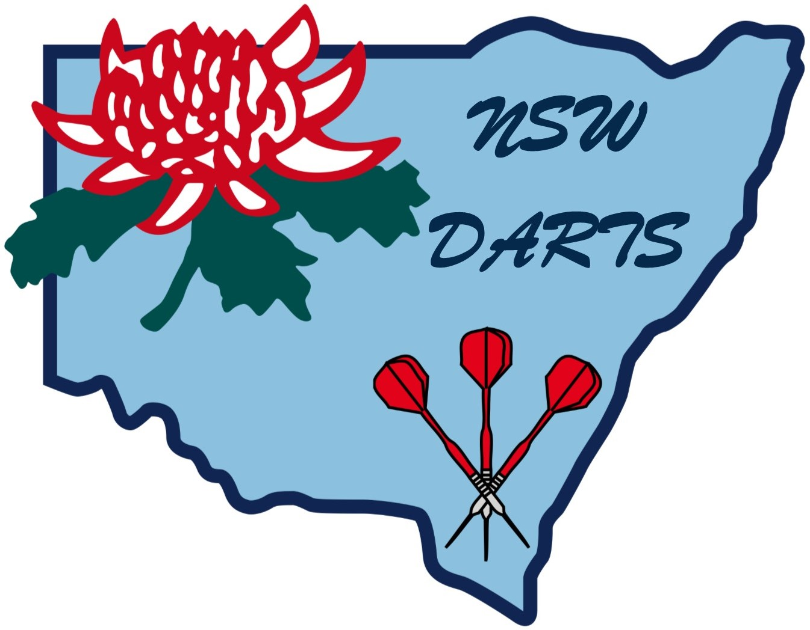

POLICY ON DRUGS

1. Application

1.1 Discovery

Any dart player found by New South Wales Darts (Inc.), Darts Australia, World Darts Federation (Inc.) or any National Darts Association (Inc.) to have used drugs or stimulants or participated in doping practices prohibited by New South Wales Darts (Inc.), Darts Australia, World Darts Federation (Inc.) or any National Darts Association (Inc.), such Association being a member, or their Affiliated Associations, will be ineligible for life for financial or other assistance from New South Wales Darts (Inc.).

1.2 Aiding and Abetting

Any Coach or Official who aids, abets, counsels, procures or is knowingly involved in a dart player’s breach of New South Wales Darts (Inc.), Darts Australia, World Darts Federation (Inc.) or any National Darts Association (Inc.), such Association being a member, or their Affiliated Associations, will be ineligible for life for financial or other support from New South Wales Darts (Inc.).

1.3 Definition

Doping or drug abuse in sports is the use by, or distribution to, a dart player or players of a substance which could have the effect of artificially improving the dart player’s physical and/or mental condition and so augment the dart player’s performance. Banned substances under this clause fall into five (5) major groupings of:

1.3.1 Stimulants

1.3.2 Narcotics

1.3.3 Anabolic Steroids

1.3.4 Non-prescribed beta blockers

1.3.5 Illegal drugs.

1.4 Professional Confidentiality

This policy does not intend to require any medical practitioner or sports scientist or psychologist or other person in professional confidentiality with a dart player to make any disclosure about the player’s contravention of the doping provisions if the knowledge of that contravention is obtained in a situation of confidentiality. This exception does not include Coaches, Administrators or any other Official appointed by New South Wales Darts (Inc.) or Affiliates Associations even if such person is a medical practitioner. Coaches are obligated to notify the State or Regional Coaching Director of New South Wales Darts (Inc.) of any alleged or suspected breaches of this policy.

2. Illegal Drugs

2.1 Restrictions

Players competing in events sanctioned by New South Wales Darts (Inc.) shall not possess or use illegal drugs whilst under the control of New South Wales Darts (Inc.) or its nominated organiser. Players found to be in possession of or using illegal drugs whilst at the venue of any sanctioned darts event shall be liable to immediate disqualification and to further disciplinary action as determined by New South Wales Darts (Inc.). The use of prescription drugs by a registered medical practitioner shall be exempted from this By-Law. The onus shall rest with the player to provide on demand any evidence that such drugs consumed at a darts event have been prescribed by a medical practitioner.

2.2 Interpretations

Generally, use of drugs will fall under four (4) basic purposes of:

2.3 Medicines

2.4 Restorative agents

2.5 Sports related medication

2.6 Performance enhancing drugs.

2.3 Medicines

Medicines are generally described as those products prescribed by a practising medical practitioner for the legitimate treatment of a specific condition; e.g. insulin, diuretics, etc. These products are not banned in the sport of darts whilst taken under these circumstances.

2.4 Restorative Agents

Restorative agents are products that are usually available from retail pharmaceutical outlets such as anti-inflammatory agents, local anaesthetics, analgesic rubs, etc. Such products are not prohibited in the sport of darts.

2.5 Performance Enhancing Drugs

Beta blockers are generally prescribed for persons suffering from coronary heart disease and hypertension. Such drugs do, however, have a side effect of controlling tremor. The use of beta blockers that are not medically indicated and prescribed but are used solely for the purpose of influencing performance is deemed illegal in the sport of darts.

2.6 Sports Related Medication

Amphetamines are a group of drugs that are chemically related to adrenalin and are used to increase wakefulness and delay fatigue.

The use of amphetamines is banned in the sport of darts.

Given the significant side effects of amphetamines, it is unlikely that players will resort to their use of they are fully aware of the side effects. Coaches and Officials should make a point of publicising these side effects which include:

2.6.1 Insomnia

2.6.2 Excessive nervousness and palpitations which seriously impede the level of performance

2.6.3 A warping of judgement that often results in the player believing they are performing well when in fact their performance is suffering

2.6.4 The loss of normal sensations of fatigue that result in the masking of the body’s normal fatigue alarm system. When the body is stressed in such conditions, collapse and even death may occur.

2.6.5 The sustained use of amphetamines can bring about a change in behaviour coupled with increased hostility and aggression.

3. TRANQUILLISERS

3.1 Non-Influencing

After careful evaluation New South Wales Darts (Inc.) has concluded that the use of tranquillisers would not support increased sports performance.

3.2 Not Prohibited

The use of tranquillisers in not prohibited in the sport of darts.

3.3 Warning on Use

Coaches and officials should be aware that, with a repetitive action sport such as darts that the majority of training (reinforcement of the mental template of the action) is undertaken in an environment when tranquillisers would not normally be used.

3.4 Effect of Tranquillisers

The effect of tranquillisers is to slow down the neuron response systems. The actual performance of the playing action under the influence of tranquillisers becomes slower and unsynchronised with the conditioned mental template of the playing action established through many hours of training. This would normally result in a performance below the player’s real skilled level.

4. Penalties

4.1 Players competing in New South Wales Darts (Inc.) sanctioned tournaments shall not possess or use illegal drugs whilst under control of New South Wales Darts (Inc.) or its nominated organisers. Players found to be in possession of or using illegal drugs whilst at the venue of any sanctioned darts shall be liable to:

$1,000.00 fine and six (6) months suspension for the first offence,
Life suspension for the second offence.

Amended October 2018

