
nsw darts
Policy on Sexual Harassment

October 2018

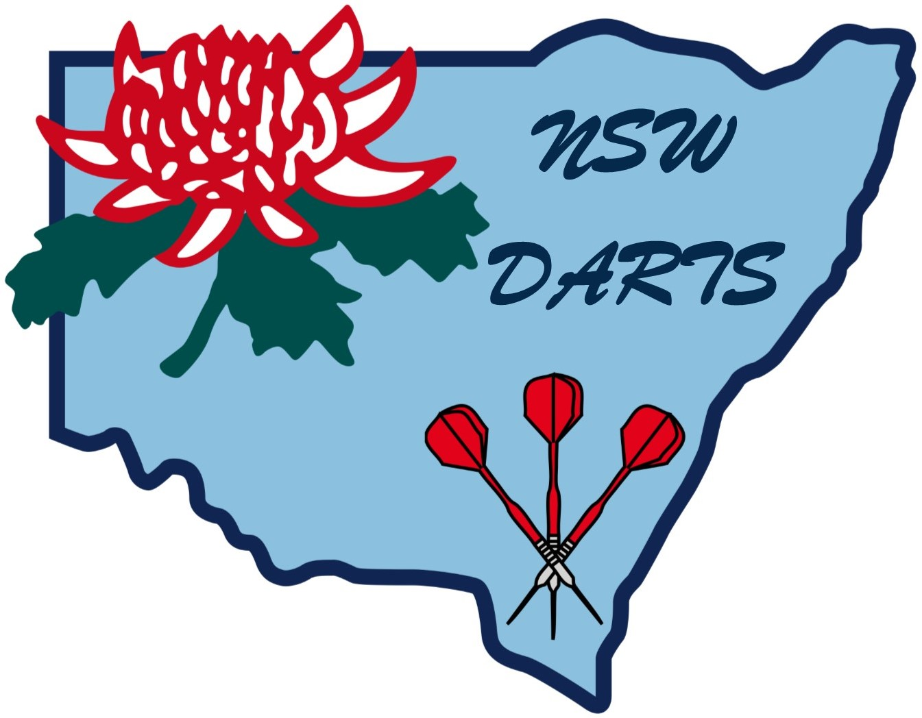
SEXUAL HARASSMENT POLICY

POLICY STATEMENT

1. NSW Darts is committed to providing a sport and work environment free of sexual harassment, where individuals are treated with respect and dignity. NSW Darts will not tolerate sexual harassment behaviour under any circumstances and will take disciplinary action against anyone who breaches the policy.

2. This policy applies to all employers, directors, officers, volunteers, coaches, athletes, officials, professional personnel and members of NSW Darts.

3. This policy applies to behaviour occurring both within and outside the course of NSW Darts business, activities and events, when the behaviour involves individuals associated with NSW Darts and negatively affects relationships within NSW Darts sport and work environment.

DEFINITION

4. For the purpose of this policy, sexual harassment is defined as behaviour that has a sexual element, that is unwelcome, and, in the circumstances, a reasonable person would have expected the behaviour would offend, intimidate or humiliate the person to whom it is directed.

5. Behaviour constituting sexual harassment can take many forms, including unwelcome physical contact, the display of offensive materials, or sexual comments, jokes and propositions. The behaviour may be a single incident or repeated. It may be explicit or implicit, verbal or non-verbal and it may include promises or threats in return for sexual favours. Although the intent may vary, if it is unwelcome and the effect is to offend, humiliate or intimidate, the behaviour should stop.

These and other examples contained in this document are by no means exhaustive. Managers are encouraged to include examples specific to their sport/environment.

RESPONSIBILITIES

6. NSW Darts is responsible for taking all reasonable steps to prevent sexual harassment and ensuring its position is widely known through all levels of NSW Darts activities.

7. NSW Darts will ensure that appropriate procedures are identified to handle sexual harassment complaints. It is further responsible for ensuring that:

- Harassment Contact Officers are identified to provide information and support
- Harassment Grievance Officers are identified and trained to mediate/conciliate grievances
- Complaints are treated in an impartial, sensitive, fair, timely and confidential manner
- Sexual harassment reporting is encouraged, regardless of who the offender might be
- Appropriate training is provided to those who manage and implement the policy
- Widespread awareness and understanding of sexual harassment is provided
- The policy and procedures are monitored and reviewed regularly.

8. All employees, members, professionals and other persons associated with NSW Darts are responsible for complying with this policy.

DISCIPLINARY ACTION

9. Disciplinary action will be taken by NSW Darts against anyone who is found to be in breach of this policy.

10. Disciplinary action will also be taken against anyone who victimises or retaliates against a person who has complained of sexual harassment.

11. The discipline will depend on the severity of the case and may involve an apology, counselling, suspension, dismissal or other form of action.

CONFIDENTIALITY

12. NSW Darts management and officers responsible for implementing this policy will keep confidential the names and details related to sexual harassment complaints, unless disclosure is necessary as part of the disciplinary or corrective process.

COMPLAINTS PROCEDURES

13. The most effective complaints procedures offer a range of options for dealing with sexual harassment. NSW Darts recognises that natural justice is the minimum standard of fairness to be applied in the investigation and adjudication of a dispute.

14. Sexual harassment complaints can be handled through a variety of mechanisms. NSW Darts recognises that, as a highly sensitive and complex matter, sexual harassment is best dealt with informally through discussion between the parties or with some assistance from an independent third party, to minimise its damaging and disruptive effects. An informal resolution is not always possible, and it may be necessary to resort to formal procedures to resolve the complaint.

15. NSW Darts encourages individuals who experience sexual harassment to inform the alleged harasser that the behaviour is unwelcome, unacceptable and contrary to policy, and ask that the behaviour stop. Individuals should also keep notes documenting incidents of the behaviour, time, place and any witnesses.

16. If it not possible to confront the alleged harasser, or of this course of action fails to stop the behaviour, then the matter should be brought to the attention of a Harassment Contact Officer, manager or supervisor for advice.

17. The role of the Harassment Contact Officer (or manager, supervisor) as a first-line-of-contact, is to serve in an unbiased/impartial capacity to listen to the complaint, offer support, provide advice on procedures and refer to a Harassment Grievance Officer when appropriate. It is not the role of the Harassment Contact Officer to try to resolve a grievance.

18. The role of a Harassment Grievance Officer is to determine whether a complaint has substance, inform the person accused of harassment of the nature of the complaint, inform both parties of their rights and responsibilities in proceeding with a grievance, act as mediator/conciliator between the parties to resolve the complaint, follow up after a complaint has been resolved to ensure there is no recurrence and refer serious matters to management, or to an eternal agency.

It is the prerogative of the complainant to decide to proceed with, or desolve a complaint.

19. NSW Darts recognises the importance of providing a choice of reporting mechanisms and officers (male and female) to complainants in order they may feel comfortable to come forward to discuss or report on an incident. NSW Darts also recognises that in some circumstances, the

manager or supervisor may be too close the problem to serve without bias. NSW Darts will ensure access to a network of Harassment Contact Officers named wither from within NSW Darts or as identified by the NSW Department of Sport and Recreation.

20. The complaint may be resolved informally between the complainant and the alleged harasser – through discussion, an apology, and a commitment to stop the behaviour. In this case, the Harassment Grievance Officer (or manager or supervisor) assisting as informal resolution will establish a follow up date to ensure the behaviour does not recur, otherwise no further action is necessary.

21. If the complaint cannot be resolved informally, the complainant may lay a formal complaint. In this case, the complainant is required to prepare and sign a formal written complaint to the Harassment Grievance Officer who, in turn will ensure the alleges harasser is provided with a copy of the complaint.

22. NSW Darts management/director responsible for this policy is responsible for ensuring the complaint is investigated and mediated or conciliated professionally and confidentially, in an unbiased and prompt manner. NSW Darts will fulfil this responsibility either a) by establishing a comparable grievance mechanism within its own structure to handle the complaint, or b) state sporting organisations can utilise the Harassment Grievance Officer pool through the NSW Sports Federation.

23. The review panel will comprise three members, at least one female and one male. Decisions of findings and recommendations of disciplinary action are the responsibility of the review panel.

24. NSW Darts will ensure that all steps in the complaint’s procedure are handled promptly, and that the period given to investigation, hearing and release of the decision does not exceed eight weeks.

RIGHT TO APPEAL

25. Both parties to a complaint have the right to appeal the decision and recommendation of a panel if a matter of procedure, bias, or fairness is called into question. An appeals panel made up of members other than those who formed the original review panel should handle formal appeals.

EXTERNAL ACTION

26. Both complainant and alleged harasser may pursue advice or action from an external authority at any stage of the complaint procedure. In NSW, the Anti-Discrimination Board is the authority responsible for receiving complaints of sexual harassment. The Human Rights and Equal Opportunities Commission is the authority responsible for receiving complaints under Commonwealth jurisdiction, and in some instances, may be the appropriate body.

POLICY REVIEW AND APPROVAL

27. NSW Darts Board of Directors approves this policy on 12 May 2011.

28. NSW Darts Director responsible for this policy will ensure a review of the policy is conducted periodically.

Amended October 2018

