
nsw darts
Policy on Volunteers

October 2018

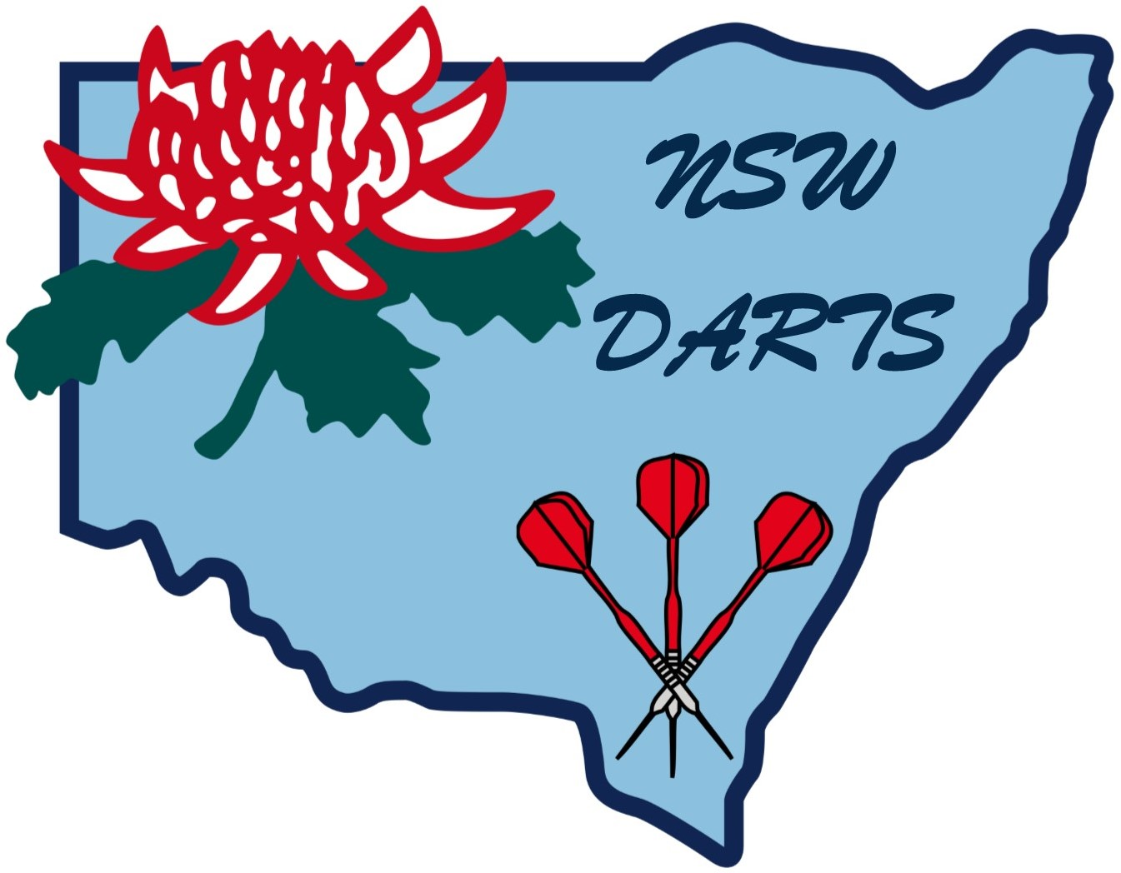

POLICY ON VOLUNTEERS

New South Wales Darts Inc relies heavily on the unpaid work of volunteers and values their contribution highly.

Purpose
This policy is intended to ensure that volunteers working with NSW Darts Inc have work that is safe, significant, fulfilling, and appreciated.

Policy
All volunteers shall be treated with respect and gratitude for their contribution.
Volunteers shall be employed at the discretion of the management of NSW Darts Inc.
Volunteers shall carry out duties assigned by the management of NSW Darts Inc.
All volunteers shall, as far as possible,
- be protected from harm
be relieved of liability for acts performed in the discharge of their volunteer functions.

Induction
All volunteers shall be offered appropriate information and training to discharge their functions, and successful completion of this training shall be a condition of carrying out these functions.

Authorisation
Greg Clegg Emily Austin Anne Day
Chairman Financial Manager Administrator

Amended October 2018

Amended June 2023

