
NSW DARTS
Policy on Alcohol

12 October 2018

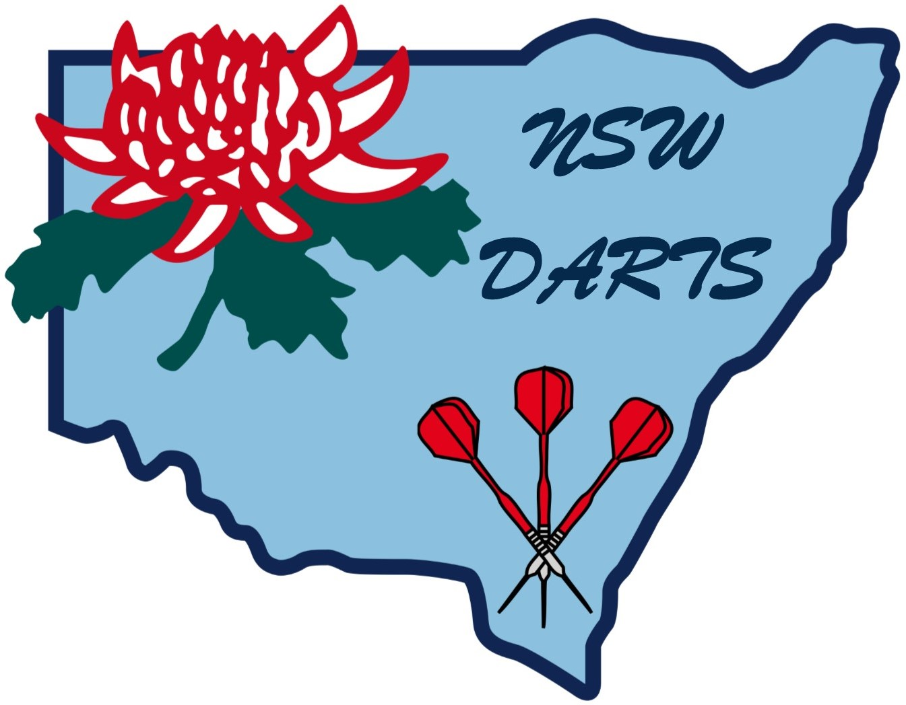

POLICY ON ALCOHOL

1. Effects

1.1 Effects on Reflexes

Contrary to popular belief, alcohol is a depressant drug that dampens the reflex mechanisms. This results in a steadying of hand together with the psychological side effect of boosting confidence by, in some cases, depressing fears and masking inhibitions.

1.2 Body Effects

The effects of alcohol on the body vary between each person and circumstances. The following immediate effects of alcohol are registered in all people to a varying extent depending on the volume consumed, the physiology and circumstances at the time:

1.2.1 Loss of inhibitions

1.2.2 Flushing and dizziness

1.2.3 General impairment of brain and nervous system functions

1.2.4 Loss of coordination to varying degrees

1.2.5 Slower reactions

1.2.6 Aggression.

2. Excess

New South Wales Darts (Inc.) is cognisant of the potential danger of accidental injury in the sport of darts. In extreme circumstances other participating players could be placed at risk by a dart player under the influence of excessive alcohol.

3. Comparison

It has been clearly established in most States and Territories of Australia that reactions and judgement of a driver of a motor vehicle are seriously impaired to the point of being dangerous if driving with a blood alcohol level in excess of 0.05%. Given the extensive research that has identified this level to be the point where accidents are more probable, it is deemed to be an appropriate maximum level of blood alcohol present in a player whilst playing darts.

4. Policy

It shall be the policy of New South Wales Darts (Inc.) that:

4.1 Individual players whilst in the venue

4.2 Individual Coaches and Officials whilst coaching and attending the players at the venue

4.3 Individual Callers, Scorers, Line Referees and Recorders

Shall be required to follow the guidelines for Responsible Serving of Alcohol. Drinking to excess will not be tolerated.

5. Alcohol

Whilst in attendance at a licensed venue, the bringing in of alcohol not purchased on the premises will not be tolerated.

6. Penalties

The penalty to be imposed shall be disqualification for the balance of the tournament, championship, etc., or for a term to be determined by the Board and/or Tournament Director.

Amended October 2018

