
NSW DARTS
Policy on Tobacco

October 2018

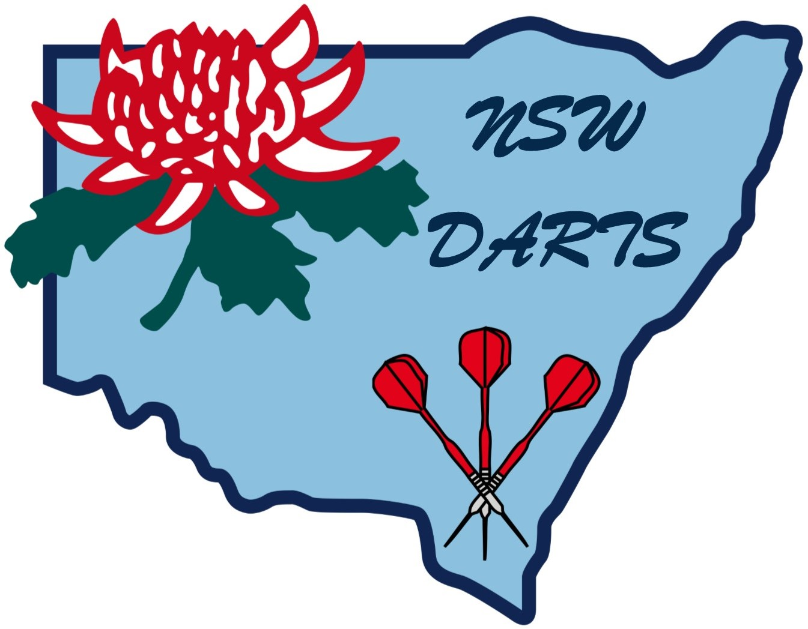

POLICY ON TOBACCO

Smoking is not permitted inside at any darts venue. Those wishing to smoke must go to the designated smoking areas of the venues.

1. Not Prohibited

Drug intake as the result of smoking is not deemed illegal in the sport of darts. However, the adverse health aspects and the decreased performance potential associated with the practice of smoking is to be actively promoted through the National Coaching Program. The principal factors include:

1.1 Conflict between a practice that is hazardous to health and the conduct of a sport. The lynch pin to the continued acceptance by Government and specialist lobby groups of a sport must be seen as being beneficial to individual’s health.

1.2 The impact of smoking upon non-smoking participants.

1.3 The quality of the image of the sport, particularly where television is involved.

1.4 The potential influencing effect on Junior Players.

2. Health Hazard

2.1 Effect on Nervous System

Nicotine is a stimulant drug that acts upon the central nervous system and is highly toxic. Nicotine is twice as deadly as arsenic and at least four times more lethal than cyanide. If the total nicotine content of one or two days of smoking was consumed in one dose it would cause death in a matter of minutes.

2.2 Smoke Contents

Inhaled smoke from a cigarette contains carbon monoxide, ammonia, hydrogen cyanide, nicotine, toluene, phenol and benzpyrene.

2.3 Passive Effect

A significant aspect with smoking is that non-smoking participants are subject to side stream smoke which contains all the above ingredients plus a number of additional gases and poisons that are not normally inhaled by the smoker due to the cigarette filter. These gases include formaldehyde, acrolein, vinylpridine, naphthalene and napthylamine.

2.4 Effect on Blood Stream

The carbon monoxide from a cigarette is rapidly absorbed in the blood stream in preference to oxygen and therefore reduces the amount of oxygen that can be carried by the red corpuscles. The tar in a cigarette reduces that elasticity of the air sacs and so restricts the volume of oxygen that can actually attempt to enter the blood stream.

2.5 Effect on Heart

Smoking increases the heart rate whilst at the same time reducing the quantity of blood flow by causing the elevation of players’ blood pressure.

3. Player Performance Effect

Darts is an anaerobic sport and therefore does not utilise oxygen as a direct energy source. Anaerobic energy systems utilise phosphate and lactic energy stored in the body. The replacement of this phosphate and lactic energy material carries with it an oxygen debt because oxygen is required to form the compounds used in these energy systems. Many of our more significant tournaments are long and tiring and the presence of smoke significantly reduces the endurance of the players in these events due to:

3.1 The reduced blood flow to the muscles and so limiting access to phosphate energy source

3.2 The reduced blood and oxygen flow to the brain inhibits concentration and clarity of thought

3.3 Body fatigue due to the build up of oxygen debt and slower replacement of the phosphate and lactic energy sources.

4. Sports Imagery

Due to the passive nature of darts New South Wales Darts (Inc.) is cognisant of the need to work harder on the imagery development to compete with the more active sports. The simple fact is that active exercise is seen to be more conducive to increased health state than that of the more passive activities of darts, pool croquet, etc.

At this point it would be detrimental to our sport to introduce wide sweeping regulations such as smoking bans at darts venues. However, the extensive Government media campaigns against smoking coupled with the active participation of all sports should bring about an attitude change amongst our players that will permit the expansion of smoking bans.

5. Policy Application

With the acceptance of darts under the N.S.W. Government (Office of Sport and Recreation) for financial assistance, we can anticipate increased expectation for New South Wales Darts (Inc.) to become more actively supportive of drugs prohibition and healthy lifestyle choices.

For these reasons it is now appropriate for New South Wales Darts (Inc.) to introduce rulings that provide for:

5.1 The banning of smoking during media interviews

5.2 To ensure all publications from New South Wales Darts (Inc.), Darts Australia, World Darts Federation, N.C.C., QUIT, etc., pointing out the adverse effects of smoking and its impact upon player performance levels, is made available to all affiliated Association members.

5.3 The education of players and officials via the National Coaching Program.

Amended October 2018

