
nsw darts
Policy on Infectious Diseases

October 2018

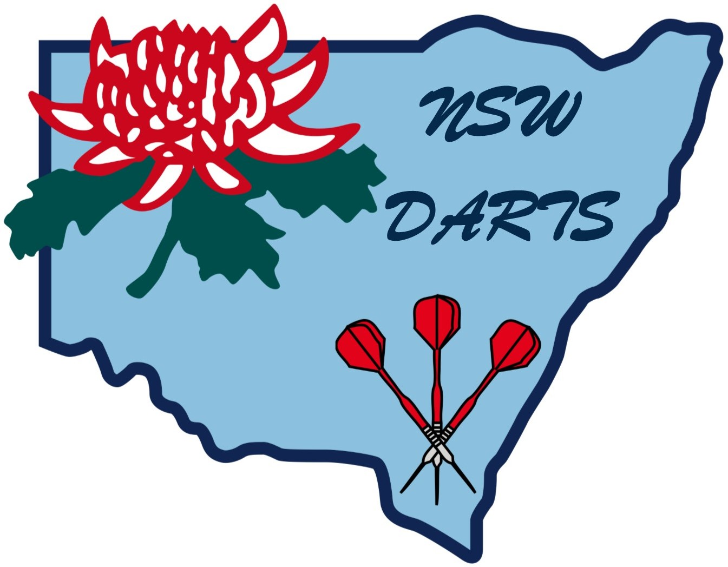

POLICY ON INFECTIOUS DISEASES

1. Application

In framing this policy, it is important to consider the types of contagion that might be applicable to the normal environment that applies to the sports of darts. The primary consideration is that darts is not a contact or collision sport.

1.1 HIV (Aids) may be spread by contact with infected players via blood.

1.2 Hepatitis B may be transferred by the medium of blood.

2. Open Cuts

All open cuts and abrasions shall be reported and treated immediately to preclude blood contamination of any item.

This is an area of principal concern to New South Wales Darts (Inc.) given that the skin can be broken very easily be contact with players and facilities or equipment.

3. Players

3.1 Personal Hygiene

It is the players’ responsibility to maintain strict personal hygiene as this is the best method of controlling the spread of infectious diseases.

3.2 Vaccinations

It is strongly recommended that all participants involved in darts and playing under adult rules be vaccinated for Hepatitis B.

3.3 Player Medical Clearances

Players with prior evidence of these diseases shall obtain clearances from a doctor prior to participation.

4. Team Areas

4.1 Responsibilities

As well as New South Wales Darts (Inc.) being responsible for Darts Australia, NSW Darts and Zone sanctioned events, it is the Affiliated Associations and their Member Clubs, joint and several, responsibility to ensure that all Dressing Rooms be clean and tidy. Particular attention shall be paid to hand basins, toilets and showers. Adequate soap dispensers, paper hand towels or air dryers, brooms, disinfectants. Etc., shall be available at all times.

4.2 Communal Bathing

Communal bathing areas, e.g. spas, shall not be used.

4.3 Spitting and Urinating

The practice of spitting and urinating in team areas shall not be permitted.

4.4 Contaminated Articles

All clothing, equipment and surfaces contaminated by blood shall be treated as potentially infectious and treated accordingly.

4.5 Sharing Articles

Sharing of towels, face washers and drink containers shall not occur.

4.6 Vaccinations

It is recommended that all personnel working in team areas should be vaccinated for Hepatitis B.

5. Tournament Officials

5.1 Reporting

Officials shall report all open cuts and abrasions at the first available opportunity.

5.2 Vaccinations

It is recommended that those who officiate should be vaccinated for Hepatitis B.

5.3 Contaminated Articles

All contaminated clothing and equipment shall be replaced prior to the player being allowed to resume play.

5.4 Recurrent Bleeding

If bleeding cannot be controlled and the wound securely covered, the player shall not be allowed to continue in the game.

6. General

If a player or official, or Association staff, is found to be suffering from Hepatitis B or HIV then that person shall not resume training or play, nor be involved in any team or match, until cleared by his or her medical practitioner or the team medical practitioner.

7. Education

There shall be an obligation upon New South Wales Darts (Inc.) to provide suitable information on the associated risk factor and prevention strategies of Hepatitis B and HIV to all our Affiliated Associations.

Amended October 2018

