
nsw darts
Policy on Pregnancy

October 2018

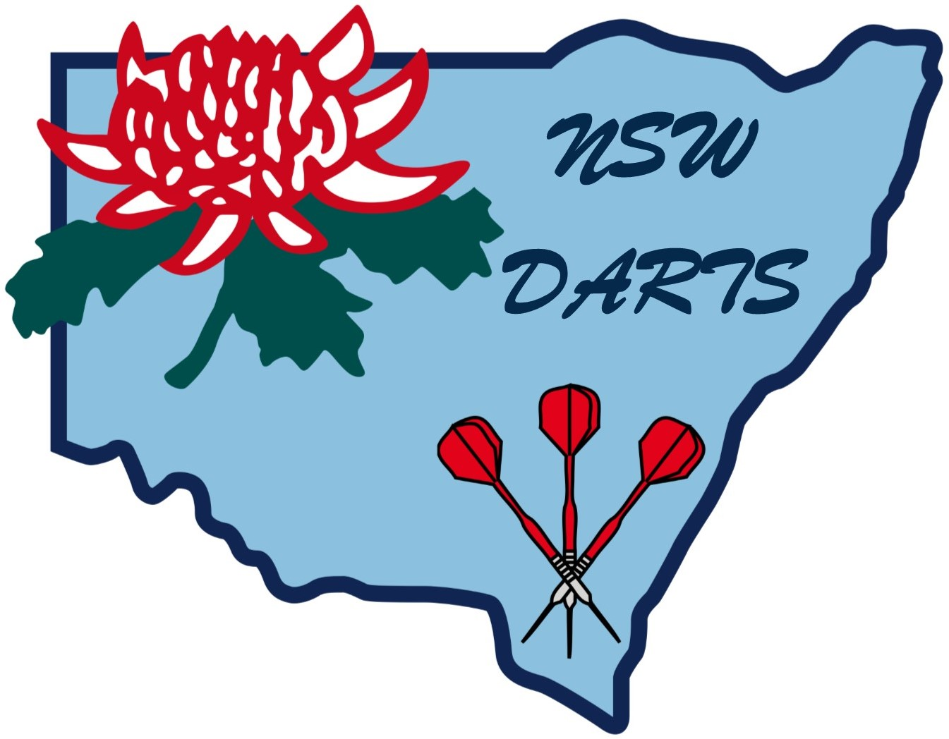

POLICY ON PREGNANCY

1. Rights

1.1 Individual Rights

New South Wales Darts (Inc.) recognises the individual right to make decisions in respect to their own person.

1.2 Players’ Rights

Any individual, however, as part of a team should recognise and respect the rights of all players to participate in the spirit of fair competition.

1.3 New South Wales Darts (Inc.) will not make any recommendations to condone the continuance in the sport if a player is pregnant. That decision shall be entirely the players.

2. Advice

2.1 Medical

New South Wales Darts (Inc.) encourages each individual player who is pregnant to seek medical advice in respect of their own medical position and the medical position of the unborn child.

2.2 Legal Advice

New South Wales Darts (Inc.) encourages the player who is pregnant to seek out any relevant advice as to their own position – legal or otherwise – regarding the mother’s potential of actual duty of care owed to the unborn child.

3. Conflict

3.1 Conflicting Opinion

New South Wales Darts (Inc.) recognises that from time to time circumstances will arise where individuals and their Affiliated Association may hold conflicting opinions in this area and New South Wales Darts (Inc.) is asked to resolve a conflict that may relate to the question of the communities right against the right of the individual.

3.2 Uniqueness of Circumstances

At all times New South Wales Darts (Inc.) recognises that each individual set of circumstances is unique to those said circumstances.

3.3 Dispute of Resolution

Should a set of circumstances arise that requires resolution, New South Wales Darts (Inc.) has adopted these following guidelines to assist in the dispute resolution process:

3.3.1 New South Wales Darts (Inc.) should at first instance make every effort to encourage the conflicting parties to attend a mediation conference.

3.3.2 This mediation should where possible be conducted as follows:

3.3.2.1 An independent mediator holding appropriate qualifications should be appointed to mediate the dispute.

3.3.2.2 A Conference should be called to seek to identify the issues that are subject to the conflict and to identify the relevant position of each of the conflicting parties.

3.3.2.3 To seek to resolve the issue in dispute

3.3.2.4 The Mediation conference should be a “Without Prejudice” Conference.

Amended October 2018

