
nsw darts
Policy on Sporting Equipment and Facility Safety

October 2018

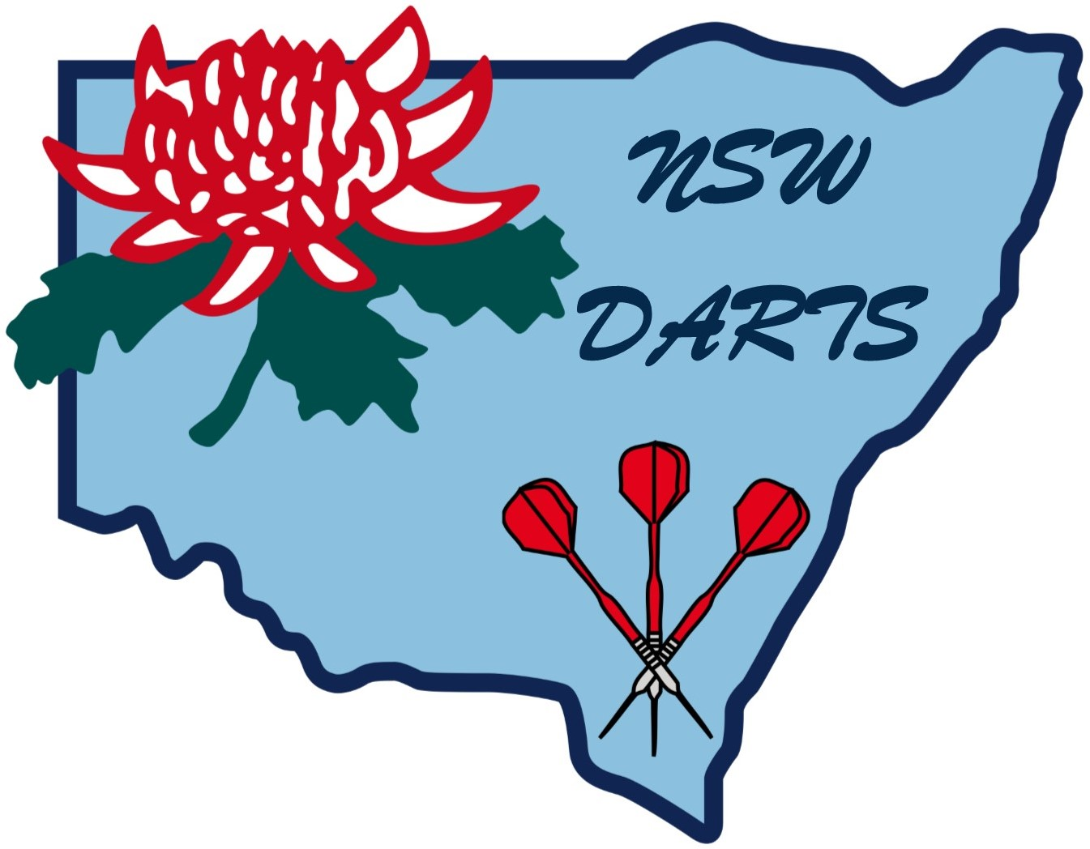

POLICY ON SPORTING EQUIPMENT AND FACILITY SAFETY

1. Application

Concern for safety should be reflected in administration policies and procedures. Administration policies and procedures should focus on two (2) aspects:

1.1 Preventative measures

1.2 Accident procedures.

2. Preventative Measures

2.1 Documentation and Record Keeping System

An effective documentation and record keeping system is crucial to any risk management system. Documentation serves a dual function:

2.1.1 It is an important part of a well organised and planned sport that can lead to the development and delivery of safer activities.

2.1.2 If it is routinely and regularly maintained, it provides a written record of procedures followed, and action taken, that can be relied upon later and may serve as factual evidence in the event of a lawsuit.

2.2 Maintenance and Inspection Reports

Maintenance and inspection reports for both facilities and equipment provide written confirmation of continuing efforts to maintain a reasonable level of safety and function that the legal standard of care requires.

2.3 Accident Reports

Detailed and accurate reports provide documentary evidence regarding the exact circumstances of an inquiry, and the emergency procedures followed.

2.4 Consent Forms

Informed consent forms provide documentary evidence that the participant understood and accepted the inherent risk of the sport and his or her obligation to exercise reasonable care.

2.5 Health/Fitness Examination Forms

The information provided in these forms will allow New South Wales Darts (Inc.) and Affiliated Associations to evaluate a player’s medical eligibility for participation.

2.6 Player’s Questionnaire

Issuing questionnaires allows New South Wales Darts (Inc.) and Affiliated Associations to gain valuable information about a player’s:

2.6.1 Skill level,

2.6.2 Physical and mental preparedness for the activity, and

2.6.3 Medical insurance coverage.

2.7 Public Relations

Strong public relations are an extremely valuable tool because players accept the safety issue when they know New South Wales Darts (Inc.), and their own Affiliated Association, is concerned about their safety and well being.

2.8 Personnel to Implement

New South Wales Darts (Inc.) and Affiliations can have the best risk management system in place but, if the risk management system cannot be properly implemented by competent personnel at all levels, it is worth very little.

2.9 Maintenance and Inspection

One of the most important elements in a risk management system is the maintenance of facilities and equipment. A system of inspection accompanying written records is essential and there are three (3) types of inspection that should be carried out.

2.9.1 Informal inspection

Members of New South Wales Darts (Inc.) and Affiliates Associations should identify and report substandard conditions or practices, and

2.9.2 General Inspection

The purpose of the general inspection is to identify normal wear and tear and general deterioration of all equipment and facilities, and to have a systematic program of reconditioning or replacement before injury occurs. Responsibility for this general inspection should be assigned to New South Wales Darts (Inc.) Venues Committee and Affiliated Associations Committee.

2.9.3 External Inspection

This involves bringing in qualified external inspectors familiar with darts facilities and equipment.

2.10 Warnings

Warnings can be either oral or in the form of a sign.

The real essence of warnings is effective communication, whether with a player or a spectator, so that the person in knowledgeable about the nature of the risk involved.

For a warning to be effective it should be:

2.10.1 Obvious and direct,

2.10.2 Specific as to the risk and should clearly indicate the risk,

2.10.3 Comprehensible and must be in language that can be clearly understood, and

2.10.4 Highly visible and should be located at the point of the hazard. It should be large enough to be easily noticed.

3. Accident Procedures

3.1 Emergency Procedures

In no area is advance preparedness more crucial than in emergency procedures. New South Wales Darts (Inc.) and Affiliated Associations shall identify all the potential emergencies to which New South Wales Darts (Inc.) and Affiliated Associations may have to respond, and work out in advance how
New South Wales Darts (Inc.) Affiliates Associations are going to respond to each type of emergency. Ensure that everyone involved is made aware of the appropriate procedures and provided with the necessary training to carry out these procedures.

3.2 Emergency Equipment

It is crucial all emergency equipment is purchased and located where it can be used in an emergency; e.g. stretcher and neck brace.

3.3 Insurance

Adequate insurance is essential and ensure that New South Wales Darts (Inc.) and Affiliated Associations understand what the terms of the insurance policy are, and the policy covers all reason of risk.

3.4 Damage Control

The way New South Wales Darts (Inc.) and Affiliated Associations respond to the player’s injury is crucial. The speed and efficiency of New South Wales Darts (Inc.) and Affiliated Associations action can directly affect the amount of damage suffered. Knowing what to do in an emergency can be difficult which is why advanced planning of emergency is essential.

3.5 First Aid

Ensure that either St. John or Sports Medicine personnel are available at the venue during regular fixture matches.

4. Practical Guidelines for Equipment Safety

4.1 General

The list of sound guidelines is suggested for New South Wales Darts (Inc.) and Affiliated Associations responsible for the provision of safe sporting equipment and facilities. The guidelines are not intended to be inclusive of all those considered to be necessary in maintaining safe equipment and facilities.

4.2 Equipment

4.2.1 Provide adequate safety equipment that meets the standards considered usual in darts, and which fits each player properly.

4.2.2 Recognise that a player is only expected to act as a reasonable person at the same age, intelligence and experience would act.

4.2.3 Instigate immediate corrective action after notice of dangerous or defective conditions of equipment.

4.2.4 Only use equipment in accordance with its intended purpose.

4.2.5 Always ensure that appropriate padding is provided on equipment or around equipment to ensure the safety of players.

4.2.6 Provide adequate storage facilities for storing darts equipment when not in use.

4.2.7 Purchase quality dart equipment from reputable dealers who will guarantee their product.

4.2.8 Designate a person to be responsible for the regular inspection of and report on equipment and removal of defective and/or worn equipment from use.

4.2.9 Detailed written records should be kept of all injuries related to defective and/or worn equipment and removal of equipment.

4.2.10 Do not give second hand equipment to junior or lower grade teams when equipment becomes worn or defective unless it has been inspected and restored to proper usable condition.

4.2.11 Avoid purchasing experimental equipment unless such equipment has been thoroughly treated and safety approved.

4.2.12 Stay up to date in the latest lines of safety equipment available.

4.2.13 Ensure the equipment fits all players.

4.2.14 Do not modify equipment unless it is in accordance with the manufacturer’s express instructions.

4.2.15 Do not let unprofessional people repair equipment.

4.2.16 Periodically evaluate all your equipment, particularly its wear and tear and its usefulness.

4.2.17 Always try to buy the very best equipment darts can afford.

4.2.18 Players themselves should be encouraged to check for common safety measurers involving their equipment.

4.2.19 Maintain all pieces of equipment according to the manufacturer’s guidelines.

5. Facilities Precautions

Provision of adequate and safe facilities requires careful attention to all sections as follows:

5.1 Providing a safe facility begins with the design stage. Use recommended standards when designing a facility.

5.2 Do not place glass objects, wires, sharp or blind corners near areas where dart activities will take place.

5.3 A safety officer and sports facility design consultant should review the plans, examining for potential safety danger spots.

5.4 Inspect facilities regularly, periodically and thoroughly for dangerous conditions and complete necessary repairs before facility is used again.

5.5 Maintain facilities at National or State Standards in relation to facilities of a similar size or focus.

5.6 Maintain facilities in good condition.

5.7 Whilst acknowledging that both players and spectators assume the risks inherent in dart activity, they do not assume the risk of dangerous or defective conditions or facilities.

5.8 Players themselves should be made to check for common safety hazards involving facilities.

5.9 Ensure all appropriate dartboard stands, stage equipment is maintained in a safe condition.

5.10 Ensure reasonable medical care is available or easily accessible to deal with injuries to players or spectators.

5.11 Limit number of players around dartboard to prevent overcrowding.

6. Conclusion

Finally, take the initiative and implement safe practices and risk management strategies, and be satisfied that New South Wales Darts (Inc.) and/or Affiliated Associations are providing a safe environment for darts.

Amended: October 2018

