
NSW DARTS
Policy on Advertising on Playing Uniforms

October 2018

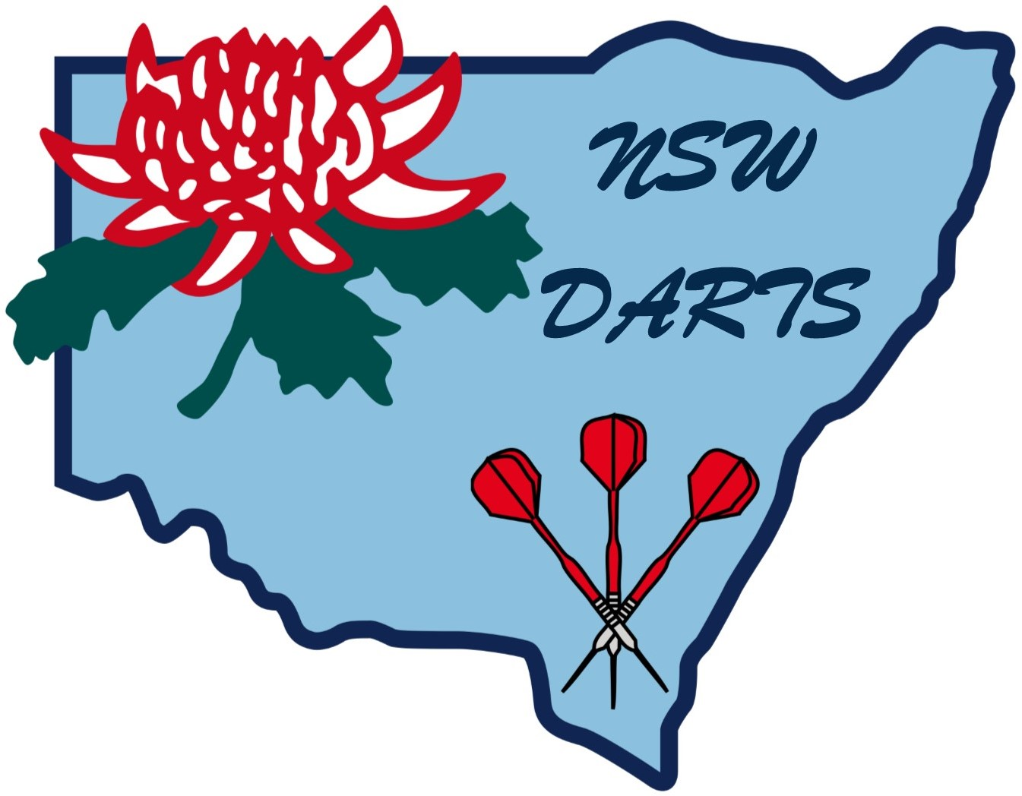

POLICY ON ADVERTISING ON PLAYING UNIFORMS

NSW Darts accepts that the majority of dart players at the elite level have personal sponsors.

NSW Darts encourages players and associations to obtain sponsorship where possible.

There can be no objection to the use of a sponsor’s name and/or logo on a playing uniform.

