
nsw darts
Policy on Office Administration

October 2018

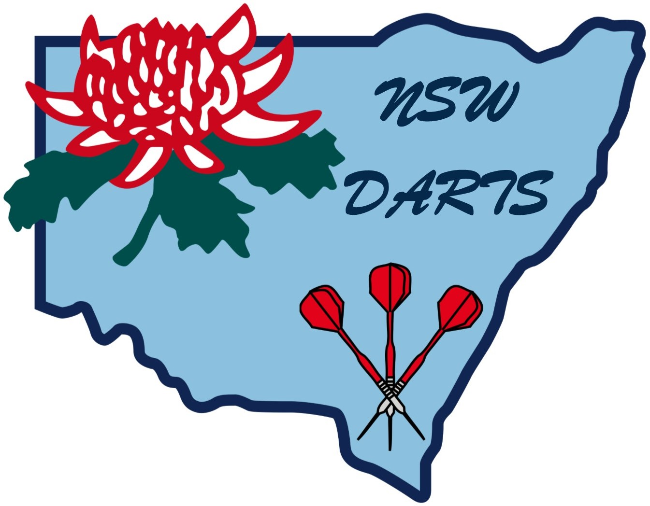

POLICY ON OFFICE ADMINISTRATION

The office of NSW Darts will be situated at the residence of the Administrator. The Administrator is responsible for the record management of all NSW Darts documents and policies.

Duties of the Administrator

- The Administrator shall cause full and accurate minutes of all questions, matters, resolutions and other proceedings of all General Meetings to be open for inspection at all reasonable times by any Financial Active Member who applied to the Administrator. For the purpose of ensuring the accuracy of the recording of such minutes, the minutes of every Board Meeting shall be signed by the Chairperson of that meeting. Similarly, the minutes of every General Meeting shall be signed by the Chairperson of that meeting. The same shall apply to the Annual General Meeting.

- Maintain a list showing inward and outward correspondence to be distributed to Active Members. Copies of correspondence to be distributed shall be at the discretion of the NSW Darts Executive or as requested by any Active Member. Executive correspondence shall be distributed at the discretion of the NSW Darts Executive

- Develop a manual of NSW Darts documents and policies for the Board of Directors.

- Produce a NSW Darts Manual containing copy of the NSW Darts Constitution, By-Laws, Playing Rules, Codes of Conduct and all other NSW Darts policies and documents pertaining to events under the control of NSW Darts.

The affairs of NSW Darts will progress on a daily basis but reviews and updating of the manual will be carried out no less than every two (2) years.

12 October 2018

