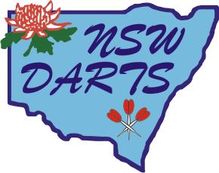
Code of Conduct for NSW Representative Players

Management of Representative teams includes the Manager (State Team Director), the Ladies Captain, the Men’s Captain and the State Coach.

- A copy of the Code of Conduct is to be given, by the State Team Director, to every representative player prior to their leaving NSW for any representative duties, preferably at the time of their selection into the team.

- All decisions made by management will be supported by NSW Darts.

- Players are to be respectful of their fellow players and management at all times and consideration of team mates, other players and management is to be given at all times.

- All members of Management are to be respectful to players and fellow management at all times.

- Players are to follow Captains or Managers decisions at all times.

- A curfew of 11.00pm applies to all players.

- Alcohol consumption is to be in moderation. Players are expected to refrain from drinking alcohol prior to commencement of play.

- Captains are to be informed of player’s whereabouts at all times.

- Visitors to player’s accommodation are to be approved by the captain before visit.

- If any player has a grievance they feel the Management have not dealt with they are to put their grievance in writing to the NSW Administrator or refrain from saying anything further on the matter.

- All current NSW State Representatives (including Juniors) must play the highest grade available at tournaments regardless of their average. This means that at our State Championships current Rep players must play Premier grade and at tournaments, if a graded event, they must play the highest grade available.

- All current NSW State Representatives (including Juniors) must wear their full playing uniform to play in any singles tournament where points are allocated, this includes all NSW affiliated tournaments & our State Singles Championships. If a current rep does not wear their playing uniform when playing singles in these events they WILL NOT be allocated the points they earn from the event.

- Headphones, ear pieces or any other potential performance enhancing equipment are not to be worn during any competition match. This includes all NSW affiliated tournaments, State Championships & Country Championships. Hearing aids are not included in this. These items can be worn during practice only, if desired, but must be removed prior to match commencing.

- Failure to follow the Code of Conduct may effect a player’s future selection in any representative teams.

NSW Darts Executive

