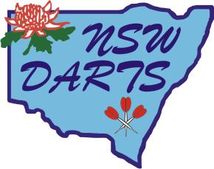

Code of Conduct for
NSW Board of Directors & Trainees

- NSW Directors & Trainees are expected to show respect for their fellow Directors at all times.

- Bringing NSW Darts name into disrepute can result in instant dismissal from the Board.

- No person shall benefit from using the name of NSW Darts for their own personal gain.

- Abusive or defamatory remarks about Directors or other persons, whether in person or on social media, will not be tolerated.

- Anything said between Directors & Trainees is strictly confidential unless stated otherwise. No conversation with other Directors, or information obtained from Board meetings, is to be discussed with any other persons.

- Whilst Directors each have their own portfolio all Directors are expected to assist each other if assistance is ever required and if Directors are able to help.

- Directors & Trainees are expected to attend all meetings circumstances permitting.

- No alcohol is to be consumed whilst attending meetings.

- No Director or Trainee shall be seen to be in an intoxicated state whilst performing official duties for NSW Darts.

- Expenses whilst performing official duties on behalf of the Council will be covered by NSW Darts.

NSW Darts Executive

