
nsw darts
Tournament and Playing Rules

October 2018

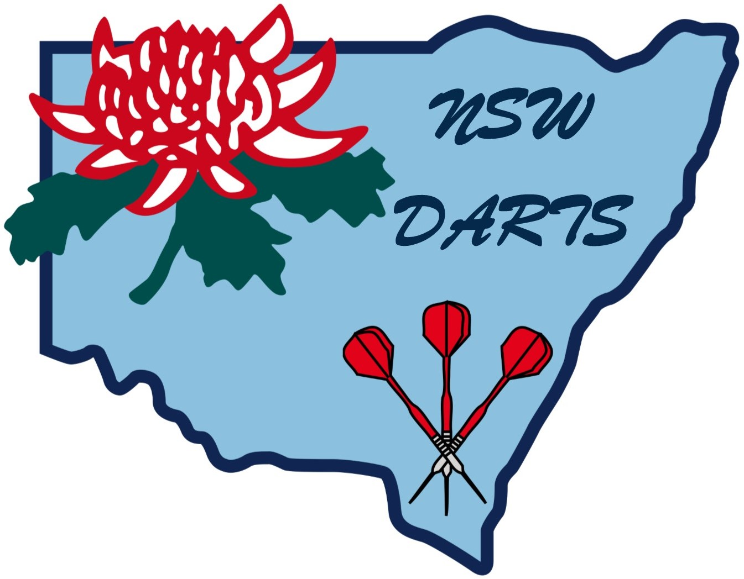
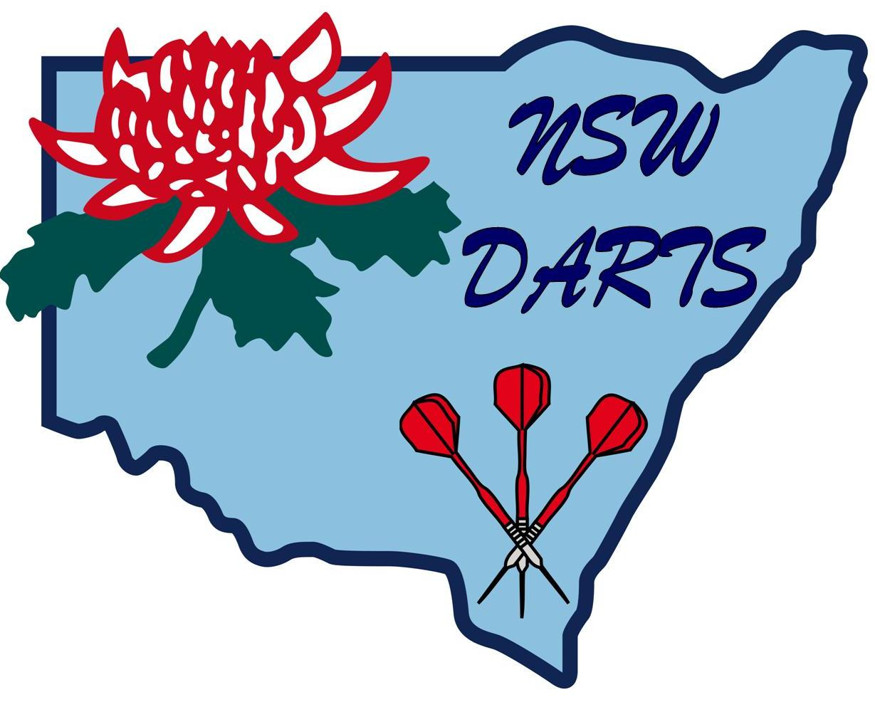
NEW SOUTH WALES DARTS

TOURNAMENT AND PLAYING RULES

FOREWORD
Organisers, Hosting Bodies and participants under these rules are subject to the Constitution, By-Laws and administration decisions of NSW Darts. In all cases the Constitution, By-Laws and administration decisions of NSW Darts shall take precedence over any clause or provision within these rules.

1. OVERVIEW

1.1 These Tournament and Playing Rules shall be known as the “New South Wales Playing Rules” and referred to herein as the “Playing Rules”.

1.2 All Zone ranked darts events throughout N.S.W. area and events conducted under the auspices of NSW Darts shall be subject to these Playing rules.

1.3 All dart players (or teams) shall play under the supervision and direction of the nominated Zone or Association organisers and officials in darts events run under the auspices of NSW Darts.

2. DEFINITIONS

2.1 For the purpose of these rules the following definitions shall apply:

2.1.1 A Referee/Scorer is the person nominated to control the proceedings of a dart game on an assigned matchboard. In the absence of a specifically nominated “referee” the person performing the function of the “caller” shall be the referee.

2.1.2 The ZONE shall mean the listed affiliates as defined by NSW Darts.

2.1.3 The word “Masters” shall only be used by NSW Darts.

2.1.4 ZONE or Zone Ranked Tournaments shall mean tournaments as approved by the ZONE as darts events that attract ranking points.

2.1.5 A Bust shall mean a score more than the value of the score remaining in the game. With a bust, the number of darts thrown are counted but no score is counted for determining the player’s average.

2.1.6 Called means that the referee has assessed the value of the score thrown and “called” the score to the “Marker” as the official score achieved.

2.1.7 The Marker is the person appointed to record all scores on the scoreboard and the score remaining as defined under Rule 22.

2.1.8 The Controller is the person responsible for the running of a darts event in accordance with these rules. Except where personal powers are afforded to the controller under these Rules, the term “Controller” is synonymous with the “Control Desk”.

The Official acting as Controller for Tournaments chosen by the Executive shall be able to request to receive out of pocket expenses.

2.1.9 Organiser – the term organiser(s) shall mean NSW Darts, its officials or persons nominated by NSW Darts to carry out its functions in relation to a darts event.

GENERAL RULES

3. ADVERTISING

3.1 NSW Darts or nominated organisers reserve the right to protect their sponsors’ interests with regard to any advertisement material used by the players, teams, organisers and other sponsors during a darts event.

3.2 Players and officials will not be allowed to wear any clothing that advertises a marketable product, or concern, that is in commercial opposition to the sponsors without the prior permission of the tournament organiser.

3.3 NSW Darts reserves the rights to all advertisement in respect to NSW Darts Sanctioned darts events.

4. PLAYING ATTIRE

4.1 All players (or teams) representing their organisation in any NSW Darts events shall wear the playing attire approved by their respective organisation. Such attire is subject to Rule 3.

4.2 All players’ attire shall conform to the good image of the sport.

4.2.1 The minimum standard of attire for men is slacks, tailored shorts with walk socks, collared shirt, fully enclosed footwear, tailored jeans.

4.2.2 The minimum standard of attire for women is skirts, divided skirts, slacks and blouses or dresses, fully enclosed footwear, tailored jeans.

4.2.3 See separate dress code for State Championships and Tournaments.

4.3 Where practicable, all players (or teams) should wear identification in the form of a recognisable team or Association uniform endorsed with the player’s name or an identification badge.

4.4 No headgear shall be worn without the prior permission of NSW Darts nominated tournament organiser. Under normal circumstances approval would only be granted for religious or medical reasons.

4.5 Enclosed footwear must be worn at all times whilst playing or scoring. If, for medical reasons, any player cannot wear enclosed footwear, a current Medical Certificate must be supplied.

4.6 Where medical conditions necessitate the wearing of attire that does not conform to the above Rules, then specific permission must be obtained from NSW Darts or its nominated organisers.

4.7 Risqué or obscene motifs or wording on clothing is not acceptable.

5. THE DART

5.1 Players shall provide their own darts. Each dart shall consist of a recognisable point, barrel and flight: -

5.1.1 Minimum overall length is 10 centimetres.

5.1.2 Maximum overall length is 20 centimetres.

5.1.3 Weigh no more than 50 grams.
6. PLAYERS’ RIGHTS

6.1 Players shall have the right to request tournament officials to check on the height of the dartboard and its distance from the toe line or oche.

7. PLAYERS’ OBLIGATIONS

7.1 All players (or teams) shall play within these rules and any supplementary rules laid down in any event specified, entry form or program provided that such supplementary rules are not in contravention of these playing rules.

7.2 Any player (or team) found guilty of deliberately losing a leg, set or match, shall be disqualified from any further participation in the NSW Darts event. That player (or team) shall also be barred from entering any NSW Darts event until such time as laid down by the NSW Darts Committee.

7.3 Any player (or team) not fulfilling their commitments by failing to complete all scheduled matches shall forfeit the right to receive any trophies, prizes or prize money in relation to that particular tournament.

7.4 If any additional expenses are incurred due to a player (or team), that player (or team) shall be liable for those additional expenses.

7.5 In the event of a player (or team) being involved in, or causing, actions considered to have brought the sport of darts into disrepute, that player (or team) shall be subject to disciplinary measures being taken against that player (or team) which could result in the imposition of fines, suspensions or other penalties.

7.6 In the Australian Championships, players representing NSW Darts must wear their playing uniforms each day during match play. Failure to adhere to this rule could mean being suspended from representative matches for NSW Darts. Any player selected to represent for ensuing period shall wear appropriate uniform at all NSW Darts State Championships and NSW Darts /Darts Australia ranked events.

7.7 Any representative of a Zone contingent playing in NSW Darts Team Championships who conducts themselves in a way detrimental to the Zone and detrimental to other personnel in the Zone contingent shall be reported to Zone who will consider what penalty the representative will incur for the misdemeanour; no consideration should be given to the result of the decision on the immoral side of this issue.

7.8 Any player in the Zone playing in NSW Darts Championships, or any other Tournament conducted by NSW Darts, who becomes under the influence of liquor and generally makes a nuisance of themselves will be reported to the Zone who will then consider what penalty that player will incur for the misdemeanours.

7.9 Any protest must be lodged with the matchboard referee/scorer at the time of the alleged violation and a judgement shall be made before any play resumes. Any late protest will not be considered.

7.10 Any player (or team) failing to comply with any of these playing rules shall be liable to disqualification from the event.

8. TROPHIES AND PRIZES

8.1 Except where stated otherwise in the published conditions of NSW Darts sanctioned tournaments, all perpetual trophies shall be held by the winning player (or team) for a period of one year and are returnable to the NSW Darts nominated organiser. However, if these perpetual trophies have not been returned for presentation, the Organisation to which that player (or team) is registered may be fined the sum of one hundred (100) dollars.

8.2 If a player (or team) representative is not present at the official presentation ceremony to receive trophies, prizes or prize monies, without the prior permission of the nominated organisers they shall forfeit the right to receive trophies, prizes or prize monies that may be due.

8.3 An Organisation shall be fined a penalty of one hundred (100) dollars per trophy their Association won at the previous tournament if that trophy was not available to be presented at the presentation of trophies.

9. INTERPRETATION

9.1 The interpretation of these playing rules in respect of any darts event shall be determined by the tournament organiser nominated by NSW Darts for the conduct of the event. The decision of the organiser shall be final and binding.

9.2 Any matter not expressly covered by these playing rules shall be determined by the NSW Darts Executive or, in their absence, the nominated tournament organiser whose decision shall be final and binding.

9.3 The interpretation of these playing rules in respect of any darts events, except where individually specified, is that the players’ protests will be determined by the organiser nominated by NSW Darts plus an official from the host Association and the referee or marker on the dartboard on the protest has arisen. The decision shall be final and binding.

10 EXPULSION

10.1 The nominated organisers reserve the right to expel any player member, or member darts body, found in breach of these playing rules. Such expulsions shall be reported, as soon as practicable, to the Zone concerned.

THE PLAYING AREA

11. AUTHORISED PERSONS

11.1 Only referee, scorer, markers and dart board indicator operators (where used) shall be allowed to stand or sit in front of the players throwing darts. Such officials are expected to restrict their movement to a minimum during “the throw”.

12. PLAYERS’ CONDUCT

12.1 No persons shall be allowed in the playing area other than those defined in Rule 11 and assigned players.

12.2 A player’s opponent must stand at least 600mm (approx. 2 feet) to the rear of the player at the oche.

12.2.1 At NSW Darts Championships this shall be 1 metre to the rear of the player.

12.3 In “stage finals” the players (or teams) shall conduct their play under the supervision and direction of stage officials and between “throws” shall be in such a position on the stage as to maximise an unrestricted view of the proceedings for players, officials, spectators and television cameras.

12.4 During match play all players shall remain silent and only the player at the oche may direct enquiries to the Referee, or Caller if no Referee is appointed.

12.5 A player at the oche shall not commence their throw until their opponent is back behind the oche. Penalty: Loss of that shot.

12.6 A player retrieving their darts after a shot shall do so promptly and in such a manner as to not interfere with the next player. Penalty: Loss of previous shot.

12.7 A player, once commencing their throw shall not leave the immediate board playing area. The playing area shall be deemed as the area between the board and the toe line with approx 600mm, where practicable, on either side of this area and 2 metres behind the toe line. Any player doing so shall forfeit that shot. There will be no drinking in front of the oche by any player, scorer or official or behind the toe line by any player for at least 1 metre.

12.8 Footwear of players must be behind the toe line at all times.

13. THE DARTBOARD

13.1 All dartboards used in tournaments conducted under these rules
:- Shall be of the bristle type.
:- Shall be of 1-20 clock pattern
:- Shall have an inner narrow band that scores “treble” segments number.
:- Shall have an outer narrow band that scores “double” segments number.
:- Shall have an outer centre ring that scores “25”.
:- Shall have an inner centre that scores “50” and shall count as double for the purpose
of finishing a leg, set or match. This inner ring shall be called the “bull”.

13.2 The dartboard shall be fixed such that the perpendicular height from the centre of the “bull” to the floor, at the same level as the oche, shall measure 1.73 metres.

13.3 The dartboard shall be fixed such that the “20” segment is coloured “black” and shall be at the top of the dartboard.

13.4 The standard dimensions of the dartboard shall be as follows
:- double and treble ring inside measurement: 8mm
:- bull inside diameter: 12.7mm
:- outer bull inside diameter: 31mm
:- centre bull to outside of treble wire: 105mm
:- centre bull to outside edge of double wire: 168mm
:- wire gauge minimum: 18 standard wire gauge
:- wire gauge maximum: 17 gauge wire gauge.
Above measurements are subject to 1mm tolerance.

14. LIGHTING

14.1 “Floor” and “wall” dartboards shall be lit by a suitably positioned light fitting to provide at least 100 watts of light intensity; alternatively, a fluorescent tube fitting of at least 18 watts intensity. The tube to be a minimum of 175mm and a maximum of 1 metre from the face of the dartboard and from the top of the dartboard is deemed to be adequate lighting.

14.2 Dartboards used in “staged finals” shall be lit by suitably positioned light fittings to provide 200 watts of light intensity; alternatively, 36 watts of fluorescent lighting mounted directly above and in front of the dartboard at a distance not exceeding 1 metre from the bullseye is deemed to be adequate.

14.3 All lights must be fitted with screens that divert the light away from players’ eyes when standing at the oche.

14.4 In “stage finals” the general level of illumination may be augmented by the use of “flood” and “spot lights” but extreme care is essential to prevent the introduction of “shadows” on the dartboard or glare in players’ eyes when standing at the oche.

15. OCHES

15.1 A raised oche of at least 25mm high and 1 metre long must be placed in a position where the throwing distance shall measure from the back of the raised oche 2.37 metres along the floor to a plumb line at the face of the dartboard.

15.2 The diagonal distance from the bull centre to the back of the raised oche at floor level shall measure 2.93 metres.

15.3 During play no player shall tread on any part of the oche, nor shall the player deliver any dart with his feet in any position other than behind the toe edge of the raised oche.

15.4 A player wishing to throw a dart from a point either side of the raised oche must keep his feet behind an imaginary straight line extending from the “toe up” face either side of the raised oche.

15.5 Any player in breach of rule 15.3 or 15.4 shall first be warned by the referee. Any dart subsequently thrown in breach of these rules shall not score. The referee may appoint an oche judge to facilitate his management of the match.

15.6 Where a repeated breach of rule 15.3 or 15.4 occurs, a team Captain or player may seek from the referee or games controller the appointment of an oche judge who shall be appointed and who will be seated in line with the oche. The oche judge shall not distract players and shall remain silent except in the case of any infringements of the oche, in which case the oche judge shall call out “No Dart” and no score shall be recorded for that dart. The referee shall pay heed to the judgement of the oche judge.

16. TOURNAMENT CONDITIONS

GENERAL CONDITIONS
Mobile Phones must be switched off in playing areas.
Singles Averages shall be taken in all events using short average system.
State Averages shall take precedence over all averages unless last known Average is higher.

The opposing teams are to keep averages as game played.
All playoffs in NSW Darts events shall be 1001, one leg.
In State Championships all winners shall be upgraded to the next highest division the next time they play in the same event.

GAMBLING IS PROHIBITED AT ALL DARTS CHAMPIONSHIPS

STATE FIXTURES

All players in all Championships are to be graded into divisions as per their individual averages (Singles Championships) or combined team average (Doubles, Sixes and Fours events).
A combined team average is calculated by adding all players’ averages in the team together and then dividing that figure by the number of players in the team.

Rules specific to each event will be issued from time to time to help clarify the conditions pertaining to that event.

State Singles, Doubles, Mixed Doubles.
These shall be played on a board system.
Singles: 501 – Straight start, Double finish; best of three (3) legs.
Doubles and Mixed: 501 – Straight start, Double finish; best of three (3) legs.
Singles and doubles: Top two from each board through to finals up to eight (8) boards.
Teams per board are subject to number of entries.
The number of legs played in finals shall be subject to the events controllers’ decision in all events.

State Sixes.
These games shall be played on a round robin system.
Subject to numbers, it may be a full or split round robin.
Top two (2) teams go through to finals.
First of group 1 will play second of group 2, etc.
In the event of two or more teams having equal points, a teams’ playoff of one (1) game, one (1) leg only of 1001 across the board will be held.
Each match shall be:
11 games played as follows:-
6 games x Singles: 501, straight start, double finish; best of three (3) legs;
3 games x Doubles: 501, straight start, double finish.
2 games x Teams of 3 players: 801, straight start, double finish; best of one (1) leg.
These 2 teams’ games are optional depending on the number of nominations in the grade and the Games controller will determine whether they will be played.
Games are to be played in the order 2 singles, 1 doubles, 2 singles, 1 doubles, 2 singles, 1 doubles.
In the event of two (2) or more teams having equal points, a playoff of one (1) game, one (1) leg of 1001 across the board shall be held.
In State Championships all winners will be upgraded the next time they play in the event in which they won.

State Fours.
These matches are to be played as a round robin format as per Sixes.
Each match shall be:
7 games played as follows:-
4 games x Singles: 501, straight start, double finish; best of three (3) legs.
2 games x Doubles: 501, straight start double finish.
1 game x Team of 4 players: 801, straight start, double finish; one (1) leg only.
Order of play is 2 singles, 1 doubles, 2 singles, 1 doubles. Teams’ game to be played if a result needed.
In the event of two (2) or more teams having equal points, a playoff of one (1) game, one (1) leg only across the board will be held.
In State Championships all winners will be upgraded the next time they play in the event in which they won.

16.1 NSW Darts and its nominated organisers reserve the right to cancel or to change dates, venues and scheduled darts events without giving prior notice. The nominated organisers also reserve the right to alter the scheduled times of play and playing format whenever deemed necessary.
16.2 All children under the age of sixteen (16) years are excluded from all NSW Darts conducted tournaments unless they are current members of the selected NSW Darts Jnr representative side or are currently in an affiliated senior competition; they may then pay by invitation of organisers.

16.3 A Speaker system shall be available at all NSW Darts Tournaments.

17. ENTRY

1. Players of an Active Member [Zone] may, with his/her Active Member’s permission, play for another Active Member when special circumstances arise.
2. Any player that does not have a checkable average must play in Premier Division.
3. All players must have played 5 games minimum with an affiliated member to be able to obtain an average for State events.

17.1 Admission fees to tournament venues, or tournament entry fees, are not refundable except on those occasions deemed appropriate by NSW Darts or its nominated organisers.

17.2 All entries must be made on officially approved entry forms, where provided, fully completed and returned together with the appropriate fee before, or on, the specified closing date.

17.3 No entry will be accepted unless strictly in accordance with all the requirements laid down on the entry form.

17.4 Only the player named on an entry form as the competing individual, or team, shall be eligible to play in the respective darts event.

17.5 The first player named on a team entry form shall assume responsibility for immediately notifying other named players in the team of the receipt and contents of all communications with the darts events received by him/her from NSW Darts or event organiser.

17.6 No player shall play in more than one (1) team in any respective darts event.

17.7 All players participating in an individual darts event must play under their legally acknowledged name.

17.8 Acceptance by NSW Darts or its nominated organisers of a player’s entry shall be deemed as an acceptance by that player (or team) of the Playing Rules covering that respective darts event.

17.9 NSW Darts or its nominated organisers reserve the right to refuse or cancel any entrant at any stage during a darts event and their decision shall be final and binding.

17.10 If a team has a vacancy (Sixes or Fours) it may be filled during the competition with a player of correct average with the permission of respective affiliated organisation.

18. REGISTRATION AT THE EVENT

18.1 All players (or teams) shall register at each event at the predetermined times advised to all players entered by way of special notice, program or tournament entry form.

18.2 Any player (or team) failing to register by the notified time shall be eliminated from the respective tournament. Entry fees shall not be refundable.

18.3 Any player (or team) not in attendance when called upon to play shall forfeit that leg, game, set or match, whichever is applicable. Entry fees shall not be refundable (see 18.4).

18.4 Only three (3) minutes shall be allowed from the time of calling over the public address system for the player (or team) to reach the Control Desk or Assigned Match Board, whenever requirement is announced.

18.5 Where a timed draw is used, players (or teams) have the right to be advised of the scheduled time of the next match of that player (or team).

19. DRAW

19.1 There will be only one draw (two draws for a two-life event) for opponents, which shall be conducted prior to the darts events. The bracket (or quadrant) system shall be adopted.

19.2 Where practicable, the nominated organisers shall arrange preliminary matches to eliminate “byes” in the first round of the darts events.

19.3 Draw sheets must be displayed in a position for convenient viewing by the contestants, officials and spectators and maintained to represent the status of the tournament.

19.4 NSW Darts or its nominated organisers reserve the right to seed players (or teams) in the draw for the darts event where considered desirable.

19.5 No substitution of players shall be allowed in any Singles (individual) darts event.

19.6 No substitutes shall be allowed after the first round of a team event unless the specific provision of the event playing rules allow for reserve members in a team, or in extenuating circumstances as allowed at the nominated organisers’ discretion.

MATCHPLAY RULES

20. THE THROW

20.1 All darts must be thrown by, and from, the hand; to be deemed as thrown, the dart must be propelled in a forward motion using some physical force, not merely dropped.

20.2 Darts must be thrown point first & not propelled flight first.

20.3 A throw shall consist of three darts unless a leg, set or match is finished in less than three darts.

20.4 Any dart that is thrown bounces off or falls out of the dartboard shall not be re-thrown.

21. STARTING AND FINISHING

21.1 In all darts events each leg shall be played with a straight start and the finish shall be on a double.

21.2 The “bull” shall count as “50” and if “50” is required to complete a leg, set or match then the “bull” shall count as double “25”.

21.3 The first player (or team) to reduce the score required to exactly zero by obtaining the required double out is the winner of that leg, set or match, whichever is applicable.

21.4 Any dart mistakenly thrown by a player, after scoring the required “double”, shall not count as the respective leg, set or match is concluded by the dart scoring the required “double”.
Interpretation: If the player throws the dart at a double and is not sure it is in or out and does not query the shot and throws another dart into the board and misses the double, throws a third dart and goes into a single and, when approaches the dartboard, finds that the double is in, the game is over and the last two darts do not count.

22. SCORING

22.1 A dart shall only score if the point remains in or touching the face of the dartboard within the outer double wire and has been “called”. In the event of a dart falling out of the board after it has been “called” it shall count as a no score unless on 170 or below.

22.2 The score is counted from the side of the segment wire in which the point of the dart enters, and remains in, the face of the dartboard (Point of Entry).

22.3 Darts shall be retrieved by the thrower but only after the score has been “called” by the referee/scorer. Retrieval of darts thrown before the referee has “called” a score may result in a “no score” being called. If the score thrown finishes the leg, as per Rule 21, the referee shall call “Game Shot”. The player must retrieve the darts before game shot rule applies; i.e. If any dart falls from the board before the player can retrieve it the score for that dart does not count.

22.4 Upon completion of each throw the referee/scorer shall decide the score thrown and communicate the score to the “Marker/Scorer” whose sole duty is to mark the scoreboard or chalkboard in accordance with Rule 22.6 and 22.7.

22.5 The “bust” rule shall apply; i.e. if a player scores more than the score required the score thrown will not count and the player shall revert to the score required prior to his/her opponent’s last throw.

22.6 The results of each player’s throw, including “bust” and “no score”, must be clearly shown on the scoreboard or chalkboard, giving the score thrown and the balance required to finish the game.

22.7 The method of marking shall be by simple subtraction as per the following example between players “A” and “B”:-
"A" |  |  |  | Versus |  |  | "B"
501 |  | 225 |  |  |  |  | 501 |  | 298
60 |  | 60 |  |  |  |  | 120 |  | 80
441 |  | 165 |  |  |  |  | 381 |  | 218
136 |  | 65 |  |  |  |  | 26 |  | 30
305 |  | 100 |  |  |  |  | 355 |  | 188
80 |  | 60 |  |  |  |  | 57 |  | 60
225 |  | 40 |  |  |  |  | 298 |  | 128

22.8 The referee, the marker and players should check all scores and subtractions made on the chalkboard after each throw.

22.9 All requests to check the score recorded, and subtractions made, must be directed to the referee/scorer and made before the players (or teams) next throw.

22.10 A protest about the score attained after the retrieval of dart or darts may not be upheld. The referee’s decision shall be final and binding.

22.11 The actual score required must be shown on the score sheet and/or the scoreboard and is clearly visible to the players and referee.

22.12 If a player asks the referee for the score remaining and the referee replies incorrectly, the following shall apply:-

(a) If the player scores the advised number and the dart is the double required to complete the score, the throw shall be called “game shot”.

(b) If the player scores less than the advised number, the value scored during that throw will be deducted from the actual score remaining; i.e. if a player is advised 60 but really needs 58 and then scores 20 only, the remaining score is 38 not 40.

(c) If the player scores more than the advised number and more than the remaining score the result is bust.

(d) If the player scores more than the advised score but less than the true remaining, the true remainder will apply; i.e. if the player needs 62, is advised 58, but throws 60, the remaining score is 2 not bust.

22.13 A player whilst at the oche may enquire of the referee/scorer the value of a score thrown or score remaining. No indication of the required “double” shall be given by the marker or referee; i.e. 32 required NOT double 16. Whilst at the oche a player may not receive advice or coaching from any competitor, official or spectator, other than provided for under Rules 22.9 and 22.12.

22.14 The referee/scorer shall act as an umpire in all matters pertaining to those Playing Rules when conducting a dart match and shall, if necessary, consult with markers and other officials before announcing any decisions during a leg, set or match.

23. ORDER OF PLAY

23.1 The order of play shall be determined by a draw or the toss of a coin prior to the commencement of the first leg. The referee/scorer shall oversee the draw or toss of coin.

23.2 All the games commence with the toss of a coin. A player from the team winning the toss shall throw first to the Bull. The player who throws his/her dart nearest to the Bull shall throw first to commence the game. The players who lose the throw for the Bull shall have second throw in the first game and throw first to commence the second leg. Should a third leg be necessary, it will commence as for the first leg; i.e. players toss to throw for Bull.

In the event of a dart being knocked out, both players shall have another throw. If dart lands in the Bull or 25 it must be removed. If both darts have landed in the Bull, it is a rethrow; the same applies if both darts landed in 25. If one dart was in the Bull and the other in 25, the player with the dart in the Bull wins the throw.

23.3 In team tournaments where all players throw in rotation, the order of players throwing must be determined and displayed on the match board before the first throw of that leg, set or match, whichever is applicable.

23.4 If a player plays out of turn the match shall be replayed from where the first error occurred. If both sides cannot agree the match controller will be called to decide on action to be taken; it could be that leg may be replayed.

24. MATCH ASSIGNMENT / RECORD / RESULT SLIP

24.1 An assignment/record/result slip shall be made out at the control desk detailing the opponents and, if appropriate, the order of play or throwing order. This slip shall be presented to the assigned matchboard referee/scorer by the player (or team) and the referee/scorer shall be responsible for ensuring that the order of play or throwing order (if appropriate) is adhered to.
24.2 The referee/scorer shall ensure that the record/result slip is completed at the end of each leg. At the end of the match the referee shall ensure that the slip is correctly completed. Clearly indicating the winning player (or team) and ensure that it is returned immediately to the control desk by the winning player (or team).

25. PRACTICE

25.1 Each player (or team) is entitled to nine (9) practice darts to be thrown at the assigned matchboard prior to the match commencing.

25.2 As a general principle practice should not be allowed on any matchboard after the darts event has officially started. However, in the event of separate practice facilities being limited, tournament organisers may authorise practice on unassigned matchboards if this does not cause any adverse effect to match play on progress or the image of the sport.

25.3 Practice boards shall be provided in, or adjacent to, the tournament room for the exclusive use of tournament players (or teams); (if enough space available).

25.4 No practice darts are permitted after the commencement of a game consisting of legs or sets. Players are to be warned by the Captain or referee/scorer should they throw practice darts between legs and a recurrence of a breach will result in the forfeiture of the next leg of the game. During team matches, practice may occur between games within a match with the approval of the tournament organiser, provided such practice does not interfere with other match play in progress on adjoining boards.

26. NSW DARTS CHAMPIONSHIPS

Rule 26 covers special provisions common to both Senior and Junior Zone Championships.

26.1 All matches played in NSW Darts Championships shall be under the direct jurisdiction of NSW Darts and shall be conducted at the venue selected for that year’s Championships.

26.2 At the General Meeting preceding the next tournament, host Associations shall present a full report on the proposed venues for tournaments including the size of the halls, distance from accommodation, refreshment arrangements, etc.

26.3 NSW Darts shall approve or otherwise instruct to the arrangements as presented under Rule 26.2.

26.4 The Dartboard:- All matches conducted by NSW Darts and Affiliated Organisations shall be played on dartboard of approved manufacture that comply with Rule 13 and approved by Darts Australia.

27. ALTERATION OF RULES

Competition Rules specific to NSW Darts Championships may be altered at the Annual General Meeting only, except as a matter of extreme expediency. An expediency amendment may be implemented following:-

(a) The receipt by NSW Darts Executive of a proposed priority alteration to the rules and that is approved for tabling as a motion by a plebiscite of Associations present.

(b) NSW Darts is empowered to make, rescind and amend such Match Rules as it may from time to time determine necessary providing such decisions are carried by the majority of all present and entitled to vote.

28. LIQUOR AND SMOKING

PLEASE NOTE: Smoking is not permitted indoors at any venue. Designated smoking areas are allocated at all venues.

(a) Liquor shall not be consumed in the playing area at any Zone Junior Championships or Playoffs.

(b) In darts events under the judicium of NSW Darts all players and officials shall refrain from consuming alcoholic beverages whilst they are participating in any match play on stage and during introductions, interviews and presentations.

(c) Players and Officials are not permitted to consume liquor in a playing area between the front of the table immediately behind the oche and the dartboard.

29. REPLACEMENT PLAYERS

In the event that a competing team should find itself short of a player, through illness or other extenuating circumstances, the following may apply:-

The Hosting Association will be requested to provide a replacement player of no higher standards than the player being replaced. If the Association affected does not have a suitable replacement, they may use the reserve of the Association requesting a replacement, such replacement to be ratified by the Management Committee.

30. DRUGS

Players competing in NSW Darts sanctioned tournaments shall not possess or use illegal drugs as per drug code Section B1 whilst under the control of Zone or its nominated organiser. Players found to be in sanctioned darts events shall be liable to immediate disqualification and to further disciplinary action as determined by the Association or its Executive.

(i) First offence: one thousand (1,000) dollars fine plus two (2) years suspension.
(ii) Second offence: Life suspension.

The use of prescription drugs duly prescribed by a registered medical practitioner shall be exempted from this By-Law. The onus rests with the player to provide evidence that any drug consumed at a darts event has been prescribed.

31. NOISE

Noise levels must be contained within the limits of reasonable team support. Tournament Controllers are authorised to exercise their judgement in this matter.

Amended October 2018

