
nsw darts
Overview

October 2018

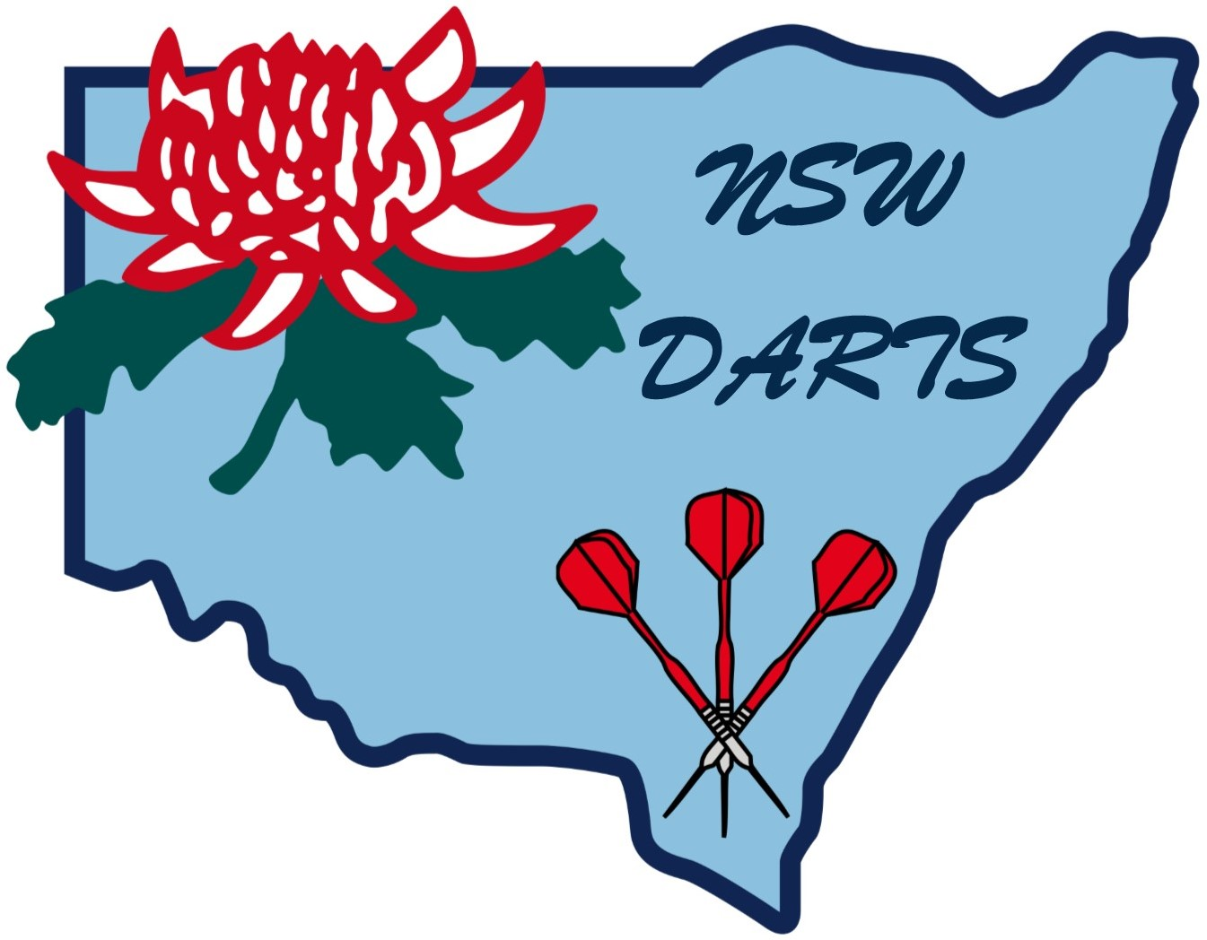
OVERVIEW (Governance)

Overview

New South Wales Darts (Inc.) Overview 29/01/2015

New South Wales Dart Incorporated is dedicated to the continued progress of the Sport of Darts in New South Wales by servicing the present and future needs of the States/Zones and their Members.

NSW Darts is committed to accomplish this by continuously distinguishing the needs of all players, administrators and supporters; demonstrate effective management, making optimum use of accessible resources and cooperating with its members in the search of excellence.

It is the mission of NSW Darts, through unity, to encourage and promote the fostering of the Sport of Darts throughout NSW/Australia.

With vision, NSW Darts will promote and develop the game of Darts for all to play. It is an objective of NSW Darts for the States/Zones to be competitive at National and International levels and to be n organisation of excellence.

NSW Darts values:

People working together
Cooperation between States/Zones, their members and the NSW Darts Board of Directors
Achieving State optimal potential
The principle of Social Justice
Professionalism and Integrity in the way we work
Friendship and Sportsmanship
Objectives

The object of NSW Darts is:

1. For the Sort of Darts to build and maintain a stronger profile in NSW/Australia as a popular and successful sport;

2. To make Darts more marketable by raising the overall profile of the sport in a way that will increase people involvement;

3. To increase the number of Dart Players by providing a service: i.e. provide an infrastructure that will attract the State/Zone members and keep them involved in the sport;

4. Provide the maximum availability of the Sort of Darts to all participants and to ensure that access and equity is not denied on the basis of gender, age, disability, cultural background or location;

5. Ensure the standard of Darts in NSW & Australia is raised to a level that will improve the opportunity for consistent success at State, National and International levels; maintain a minimum of four levels of coaching: i.e. Level 0, Level 1, Level 2, Level 4;

6. Address the issues of all groups: General [Ladies/Men], Legends, Disabled, 25’s & Under, Junior Darts in New South Wales by raising the profile of the sport at this level;

7. To establish a National Coaching infrastructure with a professional planned approach to Sports Development;

8. To seek ways of achieving financial security and independence for the Sport of Darts in all States/Zones in New South Wales;

9. Improve the business proficiency of NSW Darts by appropriately restructuring the Board of Management to meet the needs of the organisation;

10. To maintain strong representation at the Darts Australia/World Darts federation Meetings (herein after referred to as DA/ WDF) and to positively contribute to DA/WDF organised operations, policies and performances.

Greg Clegg Emily Austin Anne Day
Chairman Financial Manager Administrator

Board of Directors

Amended October 2018

Amended June 2023

